**FRIO COUNTY COMMISSIONERS COURT MINUTES FOR**

**Regular called Meeting August 13th, 2024**

On the 13th day of October, 2024, at 3:00 p.m., the Commissioners Court of Frio County met in a regular meeting with the following members either absent or present, to-wit: Rochelle Lozano Camacho, Frio County Judge was present; Joe Vela, Commissioner Pct 1 present; Mario Martinez, Commissioner Pct 2 present; Raul Carrizales, Commissioner Pct 3 present; Danny Cano, Commissioner Pct 4 present; Joseph A. Sindon, Legal Counsel for Frio County Commissioners Court present; and Aaron Ibarra, Frio County Clerk present when the following meeting was held, to-wit: The meeting can be seen unedited and to its full extent on our county website, under the County Clerk tab.

I. Invocation and Pledge of Allegiance

II. Adopt Agenda

**MOTION: COMMISSIONER CARRIZALES**

**SECOND: COMMISSIONER CANO**

**MOTION WAS MADE WITH CHANGES, MOVE ACTION ITEM #14 TO #1 AND #32 TO #2**

**MOTION: PASSES**

III. Old Business

**PRESENTATION**

**ACTION AGENDA ITEMS**

IV. General Discussion

V. Citizens To Be Heard

VI. New Business

**PRESENTATION**

**ACTION AGENDA ITEMS**

(1) Hon. Rochelle Camacho, Frio County Judge, requests:

* 1. Consider/take action on approving a Upgrade/Downgrade Service Agreement between Frio County and Medina Electric Cooperative, Inc.

1.2 If the agreement is approved, consider/take action on approving a resolution authorizing Hon. Rochelle Camacho, Frio County Judge, to sign the agreement on behalf of Frio County.

**MOTION: COMMISSIONER MARTINEZ**

**SECOND: COMMISSIONER CARRIZALES**

**MOTION PASSES**

(2) Hon. Mike Morse, Frio County Sheriff, requests:

Consider/Approve the purchase of detention staff protective stab slash resistant vests and carriers in the amount of $7616.70 utilizing line item #100-57107.5315 Uniform expenses.

**MOTION: COMMISSIONER CARRIZALES**

**SECOND: COMMISSIONER MARTINEZ**

**MOTION PASSES**

(3) Hon. Mike Morse, Frio County Sheriff, requests:

3.1 Consider/Approve agreement with McKinstry for the system diagnostic and minor repair of the smoke control system in the FCSO Jail in the amount of $21,199.00 and utilizing Jail maintenance and upgrade line item.

3.2 If the agreement is approved, consider/take action on approving a resolution authorizing Hon. Rochelle Camacho, Frio County Judge, to sign the agreement on behalf of Frio County.

**MOTION: COMMISSIONER CARRIZALES**

**SECOND: COMMISSIONER CANO**

**MOTION PASSES**

(4) Hon. Mike Morse, Frio County Sheriff, requests:

Consider and approve releasing the funds obtained from vehicle insurance claim in the amount of $25,794.67 to the FCSO for use in purchase chasing a replacement patrol vehicle.

**MOTION: COMMISSIONER CARRIZALES**

**SECOND: COMMISSIONER CANO**

**MOTION PASSES**

**BREAK AT 4:11 PM**

**MOTION: COMMISSIONER CARRIZALES**

**SECOND: COMMISSIONER CANO**

**MOTION PASSES**

**RESUME AT 4:27 PM**

**MOTION: COMMISSIONER CARRIZALES**

**SECOND: COMMISSIONER CANO**

**MOTION PASSES**

(5) Tommy Navarro, Frio County Building Maintenance Supervisor, requests:

Consider/Take Action on approving invoice #8623 from Maverick Heat & Cool Inc., for the Road & Bridge Southside Roof Top Unit Replacement located at 2207 BI 35 E Pearsall, Texas.

.

**MOTION: COMMISSIONER MARTINEZ**

**SECOND: COMMISSIONER CANO**

**MOTION PASSES**

(6) Tommy Navarro, Frio County Building Maintenance Supervisor, requests:

Consider/Take Action on approving the application with the City of Pearsall for a new commercial water meter services for the irrigation system at the Frio County Courthouse. This will include a $500.00 deposit and a $50.00 connection fee.

**MOTION: COMMISSIONER CANO**

**SECOND: COMMISSIONER MARTINEZ**

**MOTION PASSES**

(7) Tommy Navarro, Frio County Building Maintenance Supervisor, requests:

Discussion/Update from contractor Sandoval Contracting Inc, regarding the progress of the Frio County Building Improvement known as the Camino Real located at 1796 BI 35 E. Pearsall, Texas.

**ITEM WAS DISSCUSED**

(8) Tommy Navarro, Frio County Building Maintenance Supervisor, requests:

Consider/Take Action on selecting a roof contractor to replace shingles that were damaged due to hail at the following buildings: Frio County Adult Probation 515 E. Medina St & Frio County JP #3 406 S. Pecan St in Pearsall, Texas.

**MOTION: COMMISSIONER CANO**

**SECOND: COMMISSIONER CARRIZALES**

**MOTION PASSES**

(9) Hon. Pete Martinez, Frio County Treasurer, requests:

Consider/take acting on signing resolution changing the signatory on the county owned, operated, and controlled, bank account at Security State Bank, the District Clerk Fee Account, account number 100081058, by removing Ofilia Trevino, Frio County District Clerk and Lupe Esquivel, Deputy Assistant District Clerk, and replacing them with Pete Martinez, Frio County Treasurer; Rudy Alvarez, First Assistant Frio County Treasurer; Crystal Marquez, Frio County Auditor; and Raquel Mendez, Frio County Assistant Auditor.

**MOTION: COMMISSIONER MARTINEZ**

**SECOND: COMMISSIONER CANO**

**MOTION PASSES**

(10) Hon. Crystal Marquez, Frio County Auditor, requests:

10.1 Consider/take action on accepting a bid received for Fuel and Road Materials from the bids received by the specified deadline, or consider/take action on rejecting all bids received Fuel & Road Materials received by Frio County by the specified deadline.

**MOTION MADE TO REJECT ALL BIDS**

**MOTION: COMMISSIONER CANO**

**SECOND: COMMISSIONER CARRIZALES**

**MOTION PASSES**

10.2 Consider / take action on running a sealed bids ad (below) in the Frio Nueces Current once a week for two weeks pursuant to Local Government Code Sec. 262.023.  The ad will run in the Frio-Nueces Current on August 15, 2024, and August 22, 2024.  Sealed bids will be accepted in the Auditor’s office until 3:00 pm, August 30, 2024.  Bids will be opened during commissioner’s court on September 10, 2024.

**MOTION: COMMISSIONER CARRIZALES**

**SECOND: COMMISSIONER MARTINEZ**

**MOTION PASSES**

**BID NOTICE**

By order of the Commissioner’s Court of Frio County, Texas, and pursuant to Section 262.023 of the Texas Local Government Code, sealed requests for bids for the following:

1. 89 octane unleaded gasoline; # 2 low sulfur diesel fuel; dyed diesel fuel
2. Pit run base, grade 3 & 4 coated, recycled asphalt, AA black base, crushed limestone 1 ½ minus to dust, crushed limestone 1¾ minus to dust, Portland cement, CC plus cold mix asphalt, cold mix asphalt type D, reclaimed millings, CRS-2P, CMS-1P, CSS-1H, AEP primer.

For the period beginning October 01, 2024 and ending September 30, 2025

Bids will be accepted in the County Auditor’s office until 3:00 p.m. on Friday, August 30, 2024, bids received after the time indicated will be returned unopened.  Bids will be opened and read aloud during Commissioner’s Court located in the Frio County Courthouse 500 E. San Antonio St, Pearsall, TX 78061 at 3:00 pm on Tuesday, September 10, 2024.  Bids will be awarded during Commissioner’s Court at 3:00 p.m. on Tuesday, September 24, 2024.

Specifications and bid forms can be found by visiting <https://www.co.frio.tx.us/>, requested from the county auditor’s office located in the Frio County Courthouse 500 E. San Antonio St. # 3, Pearsall, TX 78061, or by email [crystal.marquez@friocounty.org](mailto:crystal.marquez@friocounty.org).

Bidders may bid on ANY ONE ITEM or ALL ITEMS and COUNTY BID FORMS MUST BE USED. Bids should be placed in a sealed envelope and on the outside of the sealed envelope clearly labeled with all items bid on, and address to: Crystal Marquez, County Auditor, 500 E. San Antonio St. #3 Pearsall, TX 78061. Frio County reserves the right to reject any and all bids and to accept the bid most advantageous to the County.

(11) Hon. Crystal Marquez, Frio County Auditor, requests:

11.1 Consider / take action on approving credit application with Sun Coast Resources Inc. for items needed for the Frio County Jail.

11.2 If the application is approved, consider/take action on approving a resolution authorizing Hon. Rochelle Camacho, Frio County Judge, to sign the agreement on behalf of Frio County.

**MOTION: COMMISSIONER CARRIZALES**

**SECOND: COMMISSIONER MARTINEZ**

**MOTION PASSES**

(12) Hon. Crystal Marquez, Frio County Auditor, requests:

Consider / take action on the acceptance of donated funds for total amount of $670.00 from to various sources for the Frio County Sheriff’s Office.

**MOTION: COMMISSIONER CARRIZALES**

**SECOND: COMMISSIONER VELA**

**MOTION PASSES**

(13) Hon. Aaron Ibarra, Frio County Clerk, requests:

Consider/take action on approving rearrangement of furniture and other implements in the Frio County Clerk’s Office.

**NO ACTION TAKEN**

(14) Hon. Danny Cano, Frio County Commissioner, Precinct No. 4, requests:

Discussion regarding property owned by Carolyn Gray that is located in Frio County between CR3829 & CR3843 outside of Dilley, Texas.

**ITEM WAS DISSCUSED**

(15) Hon. Danny Cano, Frio County Commissioner, Precinct No. 4, requests:

Discussion regarding fuel card usage by Frio County Constables.

**ITEM WAS DISSCUSED**

(16) Hon. Crystal Marquez, Frio County Auditor, requests:

Consider/take action on selecting and awarding a bid for Administration / Professional Services from the RFP’s received by the specified deadline.

**MOTION: COMMISSIONER CARRIZALES**

**SECOND: COMMISSIONER MARTINEZ**

**MOTION PASSES**

(17) Hon. Crystal Marquez, Frio County Auditor, requests:

Consider/take action on approving and signing a resolution authorizing a grant of $6,000.00 to the Home Delivered Meal Grant Program run by the Texas Department of Agriculture.

**MOTION: COMMISSIONER CARRIZALES**

**SECOND: COMMISSIONER CANO**

**MOTION PASSES**

(18) Hon. Crystal Marquez, Frio County Auditor, requests:

Discuss and/or take appropriate action to certify the revenue received, $100,000 under the CDBG Local Hazard Mitigation Fund (fund 113) and add the following line items to the 2023-2024 Budget to receipt the funds and allow expenses:

Account #: **113-40000.4350** INTERGOVERNMENTAL REVENUES

Account Name: REVENUES

Account #: **113-50000.5591** ELIGIBLE EXPENDITURES

Account Name: EXPENDITURES

**MOTION: COMMISSIONER CARRIZALES**

**SECOND: COMMISSIONER MARTINEZ**

**MOTION PASSES**

(19) Hon. Crystal Marquez, Frio County Auditor, requests:

Discuss and/or take appropriate action to certify the revenue received, $2,184,200 under the CDBG Reginal MIT MOD Fund (fund 114) and add the following line items to the 2023-2024 Budget to receipt the funds and allow expenses:

Account #: **114-40000.4350** INTERGOVERNMENTAL REVENUES

Account Name: REVENUES

Account #: **114-50000.5591** ELIGIBLE EXPENDITURES

Account Name: EXPENDITURES

**MOTION: COMMISSIONER MARTINEZ**

**SECOND: COMMISSIONER CANO**

**MOTION PASSES**

(20) Hon. Crystal Marquez, Frio County Auditor, requests:

Discuss and/or take appropriate action to certify the revenue received, $25,794.67 under the General Fund (fund 100) and add the following line items to the 2023-2024 Budget to receipt the funds and allow expenses:

Account #: **100-40000.4866** PROCEEDS INSURANCE CLAIMS

Account Name: REVENUES

Account #: **100-57207.5220** PURCHASES NON-CAPITALIZED

Account Name: SHERIFF

**MOTION: COMMISSIONER CANO**

**SECOND: COMMISSIONER MARTINEZ**

**MOTION PASSES**

(21) Hon. Crystal Marquez, Frio County Auditor, requests:

21.1 Consider / take action to approve the budget amendments to the FISCAL YEAR 2023-2024 Frio County Budget, list below:

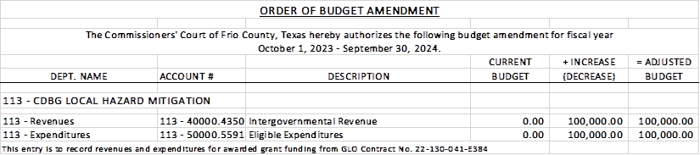

21.2 If the amendment is approved, consider/take action on signing order stating same.

**MOTION: COMMISSIONER CARRIZALES**

**SECOND: COMMISSIONER MARTINEZ**

**MOTION PASSES**

(22) Hon. Crystal Marquez, Frio County Auditor, requests:

22.1 Consider / take action to approve the budget amendments to the FISCAL YEAR 2023-2024 Frio County Budget, list below:

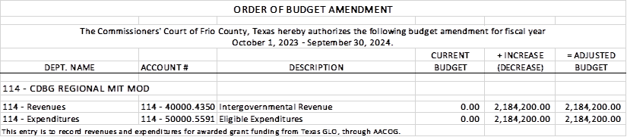

22.2 If the amendment is approved, consider/take action on signing order stating same.

**MOTION: COMMISSIONER MARTINEZ**

**SECOND: COMMISSIONER CARRIZALES**

**MOTION PASSES**

(23) Hon. Crystal Marquez, Frio County Auditor, requests:

23.1 Consider / take action to approve the budget amendments to the FISCAL YEAR 2023-2024 Frio County Budget, list below:

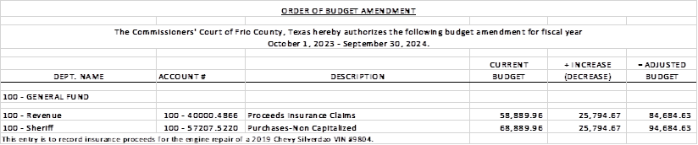

23.2 If the amendment is approved, consider/take action on signing order stating same.

**MOTION: COMMISSIONER MARTINEZ**

**SECOND: COMMISSIONER VELA**

**MOTION PASSES**

(24) Hon. Crystal Marquez, Frio County Auditor, requests:

24.1 Consider / take action to approve the budget amendments to the FISCAL YEAR 2023-2024 Frio County Budget, list below:

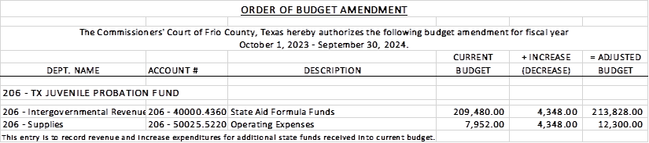

24.2 If the amendment is approved, consider/take action on signing order stating same.

**MOTION: COMMISSIONER CARRIZALES**

**SECOND: COMMISSIONER VELA**

**MOTION PASSES**

(25) Hon. Crystal Marquez, Frio County Auditor, requests:

25.1 Consider / take action to approve the budget amendments to the FISCAL YEAR 2023-2024 Frio County Budget, list below:

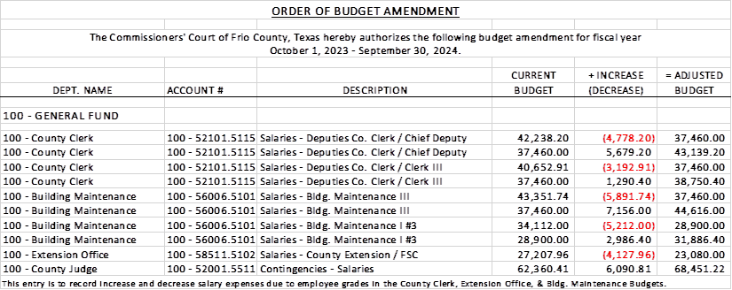

25.2 If the amendment is approved, consider/take action on signing order stating same.

**MOTION: COMMISSIONER CANO**

**SECOND: COMMISSIONER MARTINEZ**

**MOTION PASSES**

(26) Hon. Crystal Marquez, Frio County Auditor, requests:

26.1 Consider / take action to approve the budget amendments to the FISCAL YEAR 2023-2024 Frio County Budget, list below:

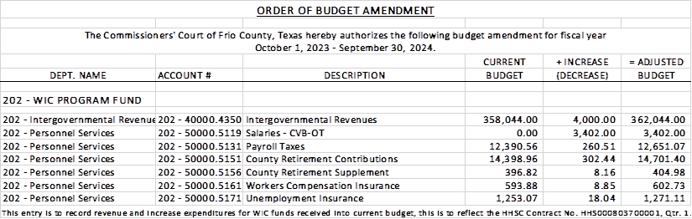

26.2 If the amendment is approved, consider/take action on signing order stating same.

**MOTION: COMMISSIONER MARTINEZ**

**SECOND: COMMISSIONER CANO**

**MOTION PASSES**

**COMMISSIONER CARRIZALES WAS ABSENT FOR THIS VOTE**

(27) Hon. Crystal Marquez, Frio County Auditor, requests:

27.1 Consider / take action to approve the budget amendments to the FISCAL YEAR 2023-2024 Frio County Budget, list below:

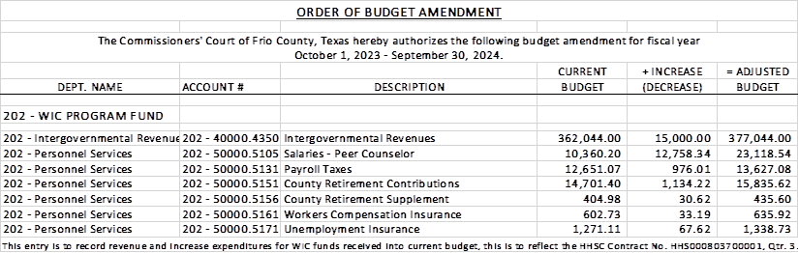

27.2 If the amendment is approved, consider/take action on signing order stating same.

**MOTION: COMMISSIONER CANO**

**SECOND: COMMISSIONER MARTINEZ**

**MOTION PASSES**

(28) Hon. Crystal Marquez, Frio County Auditor, requests:

28.1 Consider / take action to approve the budget amendments to the FISCAL YEAR 2023-2024 Frio County Budget, list below:

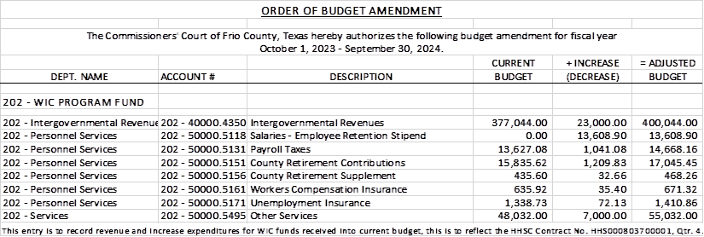

28.2 If the amendment is approved, consider/take action on signing order stating same.

**MOTION: COMMISSIONER CANO**

**SECOND: COMMISSIONER VELA**

**MOTION PASSES**

(29) Frio County Commissioners Court, requests:

29.1 Consider/take action on executing a release and settlement agreement between Frio County and S&B Infrastructure to settle and resolve all outstanding contractual amounts owed to S&B Infrastructure and authorize payment to S&B Infrastructure in the amount of $400,000.00.

29.2 If the agreement is approved, consider/take action on approving a resolution authorizing Hon. Rochelle Camacho, Frio County Judge, to sign same on behalf of Frio County.

**MOTION: COMMISSIONER CANO**

**SECOND: COMMISSIONER VELA**

**MOTION PASSES**

(30) Hon. Rochelle Camacho, Frio County Judge, requests:

Discussion and possible action to increase the fee for commercial water line and commercial sewer line permits for commercial business for the installation of utility lines in county right of ways.

**NO ACTION TAKEN**

(31) Hon. Rochelle Camacho, Frio County Judge, requests:

31.1 Consider/take action on approving Lone Star Strategy Group, LLC to apply for the Texas County Essential Services Grant Program.

31.2 Consider/take action on approving approve a Resolution in support of the Texas County Essential Services Grant Program.

**NO ACTION TAKEN**

(32) Hon. Rochelle Camacho, Frio County Judge, requests:

Discussion regarding the possible purchase of the Christian Faith Center located at 124 E. Leona St. in Dilley, Texas.

**ITEM WAS DISSCUSED**

(33) Frio County Commissioners Court, requests:

Receive in person from the following county officials the following reports as mandated by law:

33.1 Presentation by Frio County Treasurer of detailed report as mandated by Section 114.026, Local Government (“Code”) (this report is to be presented at each **regular term of commissioners court).**

33.2 Frio County Treasurer to exhibit the books and accounts of that office for the inspection of the commissioners court (**to be done at each regular term of commissioners court).**

33.3 Consider/take action on authorizing the execution by Frio County Commissioners Court (the Judge and each commissioner) of an affidavit stating the requirements of the treasurer’s report have been met as mandated by section 114.026 of the Code.

33.4 Consider/take action on execution of an order of the commissioners court approving the county treasurer’s report and order their publication in the Frio-Nueces Current as mandated by Section 114.026 of the Code or publication on the county’s website.

**MOTION: COMMISSIONER CARRIZALES**

**SECOND: COMMISSIONER CANO**

**MOTION PASSES**

(34) Frio County Commissioners Court requests:

Presentation, pursuant to Section 114.044 of the Local Government Code, by:

1. Frio County District Clerk;

2. Frio County Clerk

3. Frio County Treasurer

4. Frio County Attorney

5. Frio County Judge

6. Frio County Sheriff

7. Frio County Auditor

8. Frio County Justice of the Peace

9. Frio County Constables

**(who collects or handles any money for the use of the county) of all fines imposed, judgments rendered and collected, and all jury fees collected by the respected courts in favor of or for the use of the county and at that time when the reports are presented to present receipts vouchers that show disposition of the money, fines or judgments.**

After examination by the commissioners court as to the correctness of the reports, consider/action on directing the county clerk to enter information in county finance records as mandated by Section 114.044 of the Code.

**MOTION: COMMISSIONER CARRIZALES**

**SECOND: COMMISSIONER CANO**

**MOTION PASSES**

(35) Documents (resolutions, orders, contracts, etc.) to be signed.

(36) Allow bills payable

**MOTION: COMMISSIONER CARRIZALES**

**SECOND: COMMISSIONER CANO**

**MOTION PASSES**

(37) Adjourn

**MOTION: COMMISSIONER CARRIZALES**

**SECOND: COMMISSIONER MARTINEZ**

**MOTION PASSES**